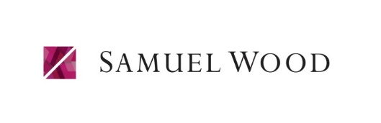
REFERRAL FEE DISCLOSURE FORM
Guidance from the Consumer Protection from Unfair Trading Regulations 2008 requires the Estate Agency sector to address the issue of transparency of fees.
Samuel Wood refers clients to carefully selected service providers because we believe you may benefit from using their services. You are not under any obligation to use any of these providers, although if you accept our recommendation the provider is expected to pay us a referral fee as listed below. This is separate from your obligation to pay our own fees or commission. Samuel Wood may also offer services for which we will charge directly; details available on request.
From the following providers we may receive a referral fee per transaction as indicated:

Martin Kaye | Solicitors | £125
Clarkes | Solicitors | £100
A V Rillo | Conveyancing Solicitors | £250
Simply Conveyancing | Conveyancing Solicitors | £200
Elite Conveyancing | Conveyancing Solicitors | £200
P Carroll Associates | Surveyors | £83
GoTo Group | Removals | £75 - £100
New Moves Removals | Removals | £75
Wicked Removals | Removals and Storage | 5%

From the following we may receive variable payments; the average per referral over the last 12 months is:

Hilltop Mortgages | Mortgages and Financial Protection | £82.30
Contractors | Property maintenance | £24.74

Occasionally a vendor is referred to us by an intermediary company to whom we are required to pay a fee out of our own commission. This includes but is not limited to: NetanAgent 0.185% of the sale price and GetAgent 0.25% of the sale price.
N.B. “Clients” includes vendors, purchasers, landlords and tenants. The above figures exclude VAT

